BSW MOVING HEAD

USER MANUAL

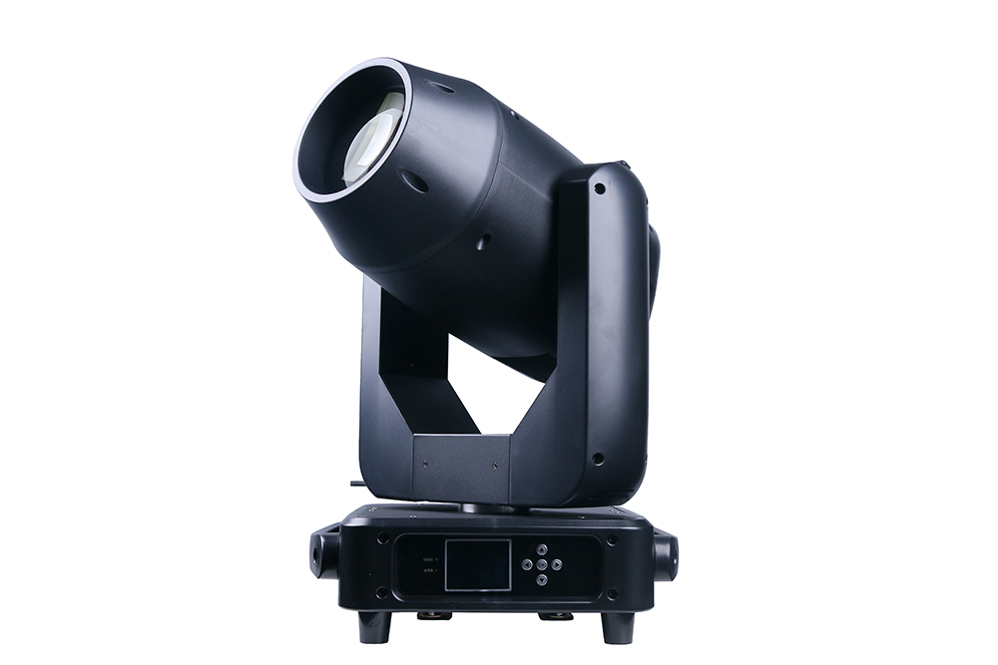

Please read and keep this manual carefully for further use!

Thank you for buying our professional Beam moving head.
This user manual includes important information for installation and operation, so please read this user manual carefully before installation and operation, and keep this user manual well for further use.
In order to install , operate, and maintain the lighting safety and correctly. We suggest that the installation and operation should be done by the verified technician and follow the instruction strictly.
Spare part includes:
Name | QTY | Unit
Fixture | 1 | PC
User manual | 1 | PC
Power cable | 1 | PC
DMX signal cable | 1 | PC
Safety rope | 1 | PC

Please check carefully that there is no damage caused by transportation. Should there be any, consult your local dealer.
Cautions
Before delivery, this device has passed strict inspection, Please follow the user manual strictly for operation, if this fixture is damaged by improper operation and mistake, the fixture will be out of warranty, and manufacture or dealer won’t be responsible for it. In case of any technology change in this manual,we won’t advise in further .



CAUTION!

Keep this device away from rain and moisture!

Unplug mains lead before opening the housing!

Warning!

Silkscreen symbol on light
Damages caused by the disregard of this user manual are not subject to warranty. The dealer will not accept liability for any resulting defects or problems.

Installation
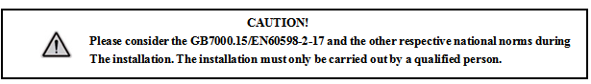

► This fixture is not suitable for direct installation on combustible material surface, please keep the fixture surface at least 0.5m from any combustible material.

► If you use the quick lock cam in hanging up the fixture, please make sure the quick lock fasteners turned in the quick lock holes correctly.
►The applicable temperature for the fixture is between -25°C to 45°C. Do not use the lighting under or above this temperature range.
►The truss for hanging the fixture should be able to hold 10 times weight of this fixture and no deformation after 1 hour hang.
►Please don’t stand under the fixture when install, uninstall, move or repair the fixture.
►Please ensure the light is connected correctly and invite professional technician to check and confirm the electrical data before installation.
►Please invite professional technician to check the fixture and installation each year.
Rigging：

Clamp
Bracket
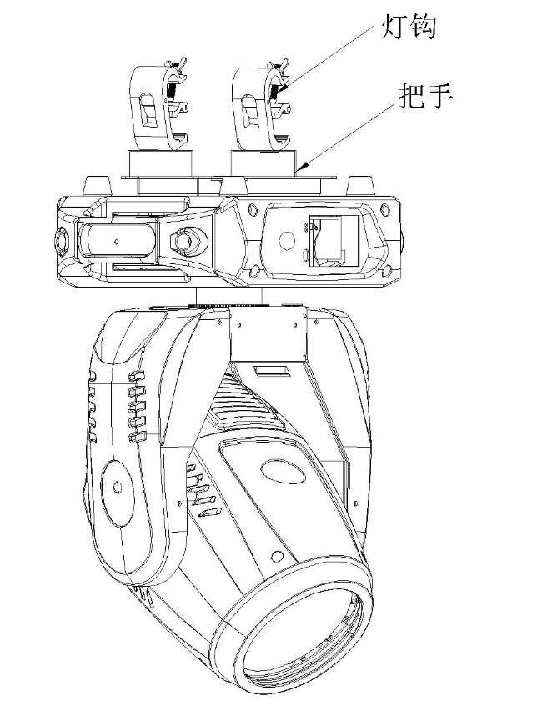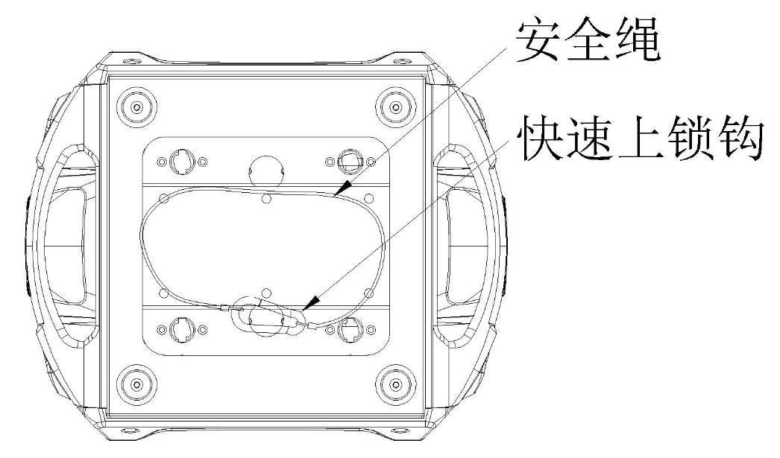
Safety rope
Quick lock

Insert the quick-lock fasteners of the first holder into the respective holes on the bottom of the device.Tighten the quick-lock fasteners fully clockwise.
Fix the clamp on truss or other fixture bracket.
Pull the safety rope through the holes on the bottom of the base and fasten it on the truss or other fixing point.
Note:This step is quite important to ensure that fixture will not drop down for the clamp damage.

Product specification

1. Voltage：100-240V，50/60HZ；
2. Power Consumption：580W；
3. Lamp:Philips 380W
4.Fuse:8A/250V，￠5*20
5.DMX Channel: 24CH
6.Operation mode: master-slave/DMX/Auto
7. Focus/Zoom: Yes
8. Fixed gobo: 11 gobos+open+ Filter
Flame plate: 2+1+1 gobos
9. Strobe: 25Hz
10. Color: 12 colors+open
11. Prism 1: 8+16-facet
12. Prism 2:16-facet
13. Pan: 540°
14. Tilt: 270°
15.Frost / Six-color effect: Yes
16. RDM: Yes
17. Display: LCD touch screen

Display and operation

Touch button | Function
Up | Option, Edit
Down | Option, Edit
Left | Backtrack, Edit
Right | Backtrack, Edit
OK | Enter to edit , confirm

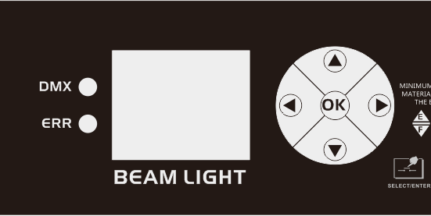

Setting:
Main Menu | Menu 1 | Menu 2
DMX setting | DMX Channel | 24CH
DMX setting | DMX signal | Hold
DMX setting | DMX signal | Clear
DMX setting | RDM | On
DMX setting | RDM | Off
DMX setting | DMX monitor
Fixture test | Auto | Off
Fixture test | Auto | On
Fixture test | Manual | 1.Color  000-255
Fixture test | Manual | 2.Shutter/strobe  000-255
Fixture test | Manual | ……
Fixture test | Manual | 19.frost  000-255
Fixture test | Reset
Fixture test | XY Reset
Fixture test | MT Reset
System Info | Temperature | Display panel temperature
System Info | Temperature | Motor board temperature
System Info | Fan | Fan speed
System Info | system version
System Info | System time | Total usage time
System Info | System time | time of this use
System Info | System time | Total lamp-on time
System Info | System time | Time of this lamp-on
System Info | Sensor monitoring | X hall
System Info | Sensor monitoring | Y hall
System Info | Sensor monitoring | color hall
System Info | Sensor monitoring | Pattern Hall
System Info | Sensor monitoring | effect pattern hall
System Info | Sensor monitoring | Glass gobo hall
System Info | Sensor monitoring | Focus Hall
System Info | Sensor monitoring | Zoom Hall
System Info | Sensor monitoring | Prism 1 Hall
System Info | Sensor monitoring | Prism 2 Hall
System Info | Sensor monitoring | X encoding status
System Info | Sensor monitoring | Y encoding status
System Info | Sensor monitoring | X encoding step value
System Info | Sensor monitoring | Y encoding step value
System Info | system error
Fixture setting | Language | English
Fixture setting | Language | Chinese
Fixture setting | screen flip off | off
Fixture setting | screen flip off | on
Fixture setting | screen saver | on
Fixture setting | screen saver | off
Fixture setting | X reverse | off
Fixture setting | X reverse | on
Fixture setting | Y reverse | off
Fixture setting | Y reverse | on
Fixture setting | XY swap | off
Fixture setting | XY swap | on
Fixture setting | XY encoder | on
Fixture setting | XY encoder | off
Fixture setting | Linear change of color wheel | on
Fixture setting | Linear change of color wheel | off
Fixture setting | reset
Factory setting  (The password is "up up down down". ) | Motor Calibration | X
Factory setting  (The password is "up up down down". ) | Motor Calibration | Y
Factory setting  (The password is "up up down down". ) | Motor Calibration | Color
Factory setting  (The password is "up up down down". ) | Motor Calibration | Pattern
Factory setting  (The password is "up up down down". ) | Motor Calibration | effect pattern
Factory setting  (The password is "up up down down". ) | Motor Calibration | Glass gobo
Factory setting  (The password is "up up down down". ) | Motor Calibration | focus
Factory setting  (The password is "up up down down". ) | Motor Calibration | zoom
Factory setting  (The password is "up up down down". ) | Motor Calibration | Dimming zero
Factory setting  (The password is "up up down down". ) | Motor Calibration | Dimming stroke
Factory setting  (The password is "up up down down". ) | Motor Calibration | Prism 1 Zero
Factory setting  (The password is "up up down down". ) | Motor Calibration | Prism 1 stroke
Factory setting  (The password is "up up down down". ) | Motor Calibration | Prism 2 Zero
Factory setting  (The password is "up up down down". ) | Motor Calibration | Prism 2 stroke
Factory setting  (The password is "up up down down". ) | Motor Calibration | Forst stroke
Factory setting  (The password is "up up down down". ) | Stroke calibration | X stroke
Factory setting  (The password is "up up down down". ) | Stroke calibration | Y stroke
Factory setting  (The password is "up up down down". ) | Stroke calibration | Focus stroke
Factory setting  (The password is "up up down down". ) | Stroke calibration | Zoom stroke
Factory setting  (The password is "up up down down". ) | XY speed adjustment | X speed
Factory setting  (The password is "up up down down". ) | XY speed adjustment | Y speed
Factory setting  (The password is "up up down down". ) | Fan adjustment | White-on fan
Factory setting  (The password is "up up down down". ) |  | Color-on fan
Factory setting  (The password is "up up down down". ) |  | White-off fan
Factory setting  (The password is "up up down down". ) |  | Color-ff fan

24 DMX channel
24CH | Function | Value | Details
CH1 | Color wheel | 000-004  005 -009  010 - 014  015 - 019  020 - 024  025 - 029  030 - 034  035 - 039  040 - 044  045 - 049  050 - 054  055 - 059  060 - 064  065 - 069  070 - 074  075 - 079  080 - 084  085 - 089  090 - 094  095 - 099  100 -104  105 -109  110 -114  115 -119  120 -124  125-129  130 -192  193 - 255 | White  White+Color 1  Color 1  Color 1+color 2  Color 2  Color 2+color 3  Color 3  Color 3+color 4  Color 4  Color 4+color 5  Color 5  Color 5+color 6  Color 6  Color 6+color 7  Color 7  Color 7+color 8  Color 8  Color 8+color 9  Color 9  Color 9+color 10  Color 10  Color 10+color 11  Color 11  Color 11+color 12  Color 12  Color 12+White  Forward flow (from fast to slow)  Reverse flow (from slow to fast)
CH2 | Shutter /strobe | 000-003  004-250  251-255 | Shutter closed  Strobe from slow to fast  Open the shutter → (controlled by the dimming channel)
CH3 | dimmer | 000-255 | dimmer from dark to bright

CH4 | gobo wheel | 000 - 004  005 - 009  010 - 014  015 - 019  020 - 024  025 - 029  030 - 034  035 - 039  040 - 044  045 - 049  050 - 054  055 - 059  060 - 064  065 - 069  070 - 074  075 - 079  080 - 084  085 - 089  090 - 094  095 - 099  100 - 104  105 - 109  110 - 114  115 - 119  120 - 187  188 - 255 | gobo 1  gobo 2  gobo 3  gobo 4  gobo 5  gobo 6  gobo 7  gobo 8  gobo 9  gobo 10  gobo 11  gobo 12  gobo 1 shake slow to fast  gobo 2 shake slow to fast  gobo 3 shake slow to fast  gobo 4 shake slow to fast  gobo 5 shake slow to fast  gobo 6 shake slow to fast  gobo 7 shake slow to fast  gobo 8 shake slow to fast  gobo 9 shake slow to fast  gobo 10 shake slow to fast  gobo 11 shake slow to fast  gobo 12 shake slow to fast  Reverse flow (from fast to slow)  Forward flow (from slow to fast)
CH5 | Effect gobo | 000 - 009  010 - 019  020 -029  030 - 114  115 - 134  135 - 154  155 - 255 | gobo 1 (blank)  gobo 2  gobo 3  gobo 4 (water pattern)  gobo 2 shake slow to fast  gobo 3 shake slow to fast  gobo 4 (water pattern) slow to fast
CH6 | Glass gobo | 000 - 009  010 - 019  020 -029  030 -039  040 - 049  050 -059  060 - 069  070 - 079  080 - 089  090 - 099  100 - 109  110 - 119  120 - 129  130 - 139  140 - 149  150 - 200  201 - 255 | gobo 1  gobo 2  gobo 3  gobo 4  gobo 5  gobo 6  gobo 7  gobo 8  gobo 2 shake slow to fast  gobo 3 shake slow to fast  gobo 4 shake slow to fast  gobo 5 shake slow to fast  gobo 6 shake slow to fast  gobo 7 shake slow to fast  gobo 8 shake slow to fast  Forward flow (from fast to slow)  Reverse flow (from slow to fast)
CH7 | Glass gobo rotation | 000-127  128-191  192-255 | Angle adjustment  Forward rotation fast to slow  Reverse rotation slow to fast
CH8 | Prism 1 | 000-127  128-255 | no effect  prism 1
CH9 | Prism1 rotation | 000-127  128-191  192-255 | prism angle adjustment  Reverse rotation fast to slow  Forward rotation slow to fast
CH10 | Prism 2 | 000-127  128-255 | no effect  prism 2
CH11 | Prism2 rotation | 000-127  128-191  192-255 | prism angle adjustment  Reverse rotation fast to slow  Forward rotation slow to fast
CH12 | Zoom | 000-255 | Pattern clarity from far to near
CH13 | focus | 000-255 | Pattern clarity from far to near
CH14 | pan | 000-255 | 0-540 degree
CH15 | pan fine | 000-255 | 0-1.2 degree
CH16 | tilt | 000-255 | 0-270 degree
CH17 | tilt fine | 000-255 | 0-1.2 degree
CH18 | XY speed | 000-255 | speed fast to slow
CH19 | frost | 000-127  128-255 | no function  frost
CH20 | Lamp control & Reset | 000-099  100-105  200-205  250-255 | no function  Lamp off  Lamp on  all motors reset
CH21 | Hold | 000-255
CH22 | Color speed | 000-255 | Speed from slow to fast
CH23 | Dimmer speed | 000-255 | Speed from slow to fast
CH24 | gobo speed | 000-255 | Speed from slow to fast

Gobo wheel Flame plate
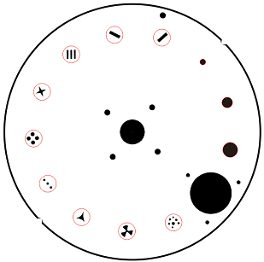
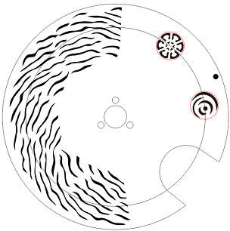

Color wheel Rotation wheel
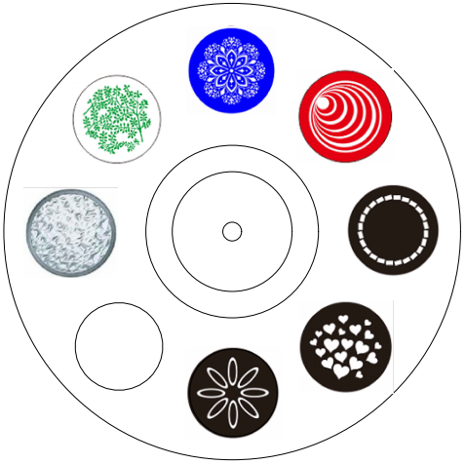
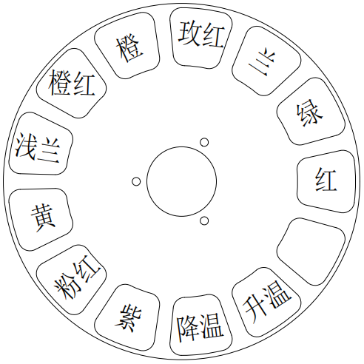

DMX-512 connection

Connect the provided XLR cable to the male 3-pin XLR output of your controller and the other side to the female 3-pin XLR input of the light.then connect the DMX signal to the first fixture to the 2nd fixture, after all fixtures are connected,

The signal cable should be two - core with screened cable with XLR input and output connectors. Please refer to the diagram below

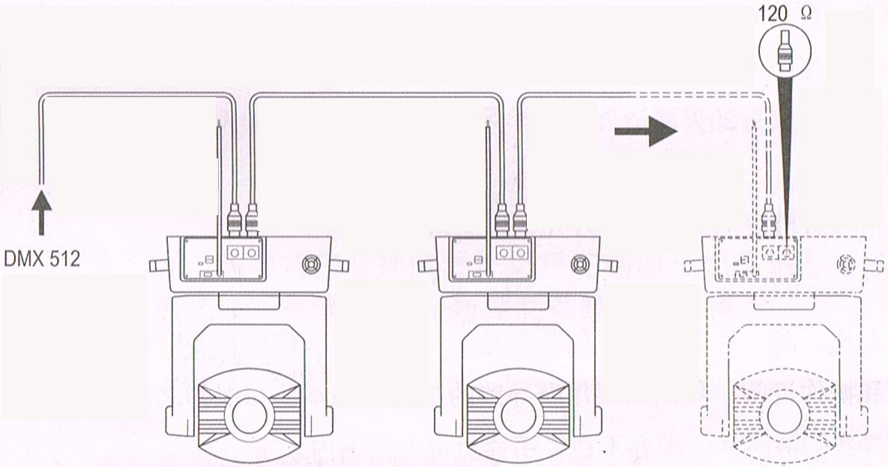

DMX terminator connection
If there are many lines or lights, it is recommended to use a DMX terminator to prevent DMX signal corruption, the DMX terminator is an simple XLR plug with a 120 Ω resistor connected between pins 2 and 3,which is then plugged into the output XLR socket of the last fixture in the chain.
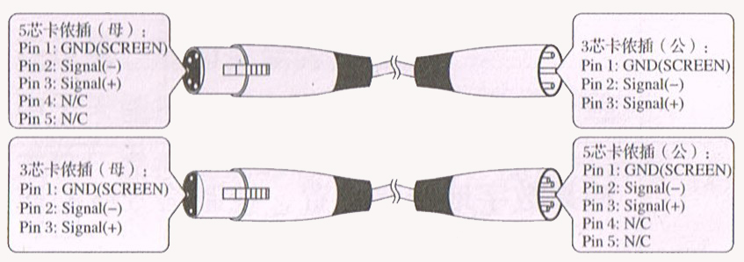
3-Pins connection
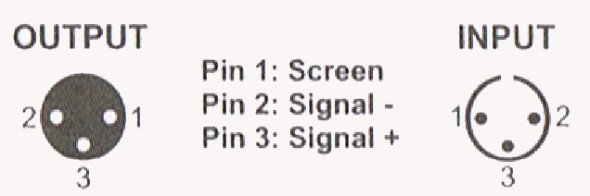
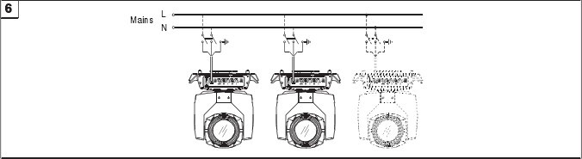
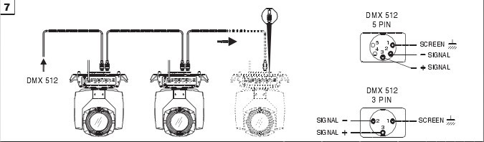

Cleaning and maintenance

Cleaning should be performed every 15-day period, by using a sponge which is dipped with alcohol, rather than wet cloth or other chemical liquid, to clean the mirror.

Cut off power before cleaning and maintenance!
CAUTION

Attention

Do not see directly light source when open the light, and make sure power off before do any installation or maintenance.

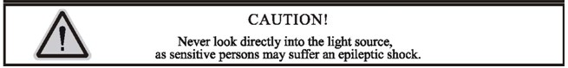
 Wires connection must be done professional person!
CAUTION

Cautions
Before delivery, this device has passed strict inspection, Please follow the user manual strictly for operation, if this fixture is damaged by improper operation and mistake, the fixture will be out of warranty, and manufacture or dealer won’t be responsible for it. In case of any technology change in this manual,we won’t advise in further .

Common issues instruction

Issues | Solve instruction
No power | Check power’s voltage
When power in, output light but the device cannot accept control signal | Check address setting and the control DMX cable connection well or not
The effect have light shadow | Check electronic focus DMX channel value, if it’s suitable distance
Light beam dim | The lamp maybe arrived end of using life, should change new lamp, and also check light source cleaning or not
Note: the maintenance should be done by the verified technician.

Warranty Card
This product is made of high-brightness transistor. We will provide 1 year warranty under the condition that user has operated the light normally and lifetime service. We won't provide warranty if the damage is caused by artificial or force majeure event. Cost of fittings should be charged by user if product need maintenance after 1 year .Please cut this warranty card and shipped it along with the product to our factory when applying for warranty.
Product：
Purchasing date：
Code of invoice：
Warranty date: From To
User’s name： Add：
Company： Tel：

